***Design Thinking Report***

**Introduction:**

Design thinking is a problem-solving methodology that emphasizes empathy, collaboration, and iteration to create innovative solutions. In this report, we delve into the detailed steps and descriptions of design thinking, examining evidence for each phase. Additionally, we explore the assessment points for design thinking and its impact on individual reflections. Moreover, it’s a practical approach because it focuses on understanding people and their needs. By doing this, we can find innovative solutions to problems that might seem complicated at first. This process encourages us to be creative and think in new ways, avoiding sticking to the usual ways of solving problems. Through design thinking, we aim to make decisions based on what people really need, rather than just guessing or taking risky chances.

There are five phases of Design Thinking. The five phases are as follows:

● Emphasize – approach your users.

● Define – state your user’s need, problems, and your insights.

● Ideate – generating ideas based on problem-solving.

● Prototype – adopting a hands-on approach.

● Testing – solutions

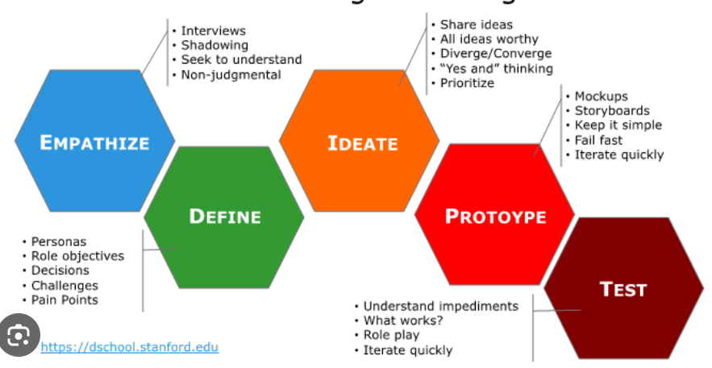

1. **Empathize**

The initial step in the Design Thinking process is empathy. In this phase, the focus is on actively observing and connecting with users to discover their needs and gain a deeper understanding of their challenges. Empathy plays a vital role in shaping a process centered around humans, as it encourages us, the thinkers, to approach the situation with a logical mindset, setting aside our own preconceived assumptions.

1. **Define**

In this particular stage, we examine the information and observations we collected in the previous phase. Our goal is to consolidate and synthesize this data to precisely define the central issues or, more specifically, to create a problem statement that revolves around the needs of people. The define phase is instrumental in generating innovative ideas to address these problems, or at the very least, it facilitates users in resolving their issues with minimal difficulty.

1. **Ideate**

In this phase, we initiate the generation of ideas, building upon the insights gained in the preceding stages. Having developed a strong foundation by understanding our user's needs in the empathize phase and crafting a problem statement in the define phase, we are well-equipped for creative ideation. Various techniques, including brainstorming, are employed to produce a multitude of ideas aimed at formulating solutions. The emphasis in this phase is on fostering creativity and thinking innovatively, encouraging the exploration of unconventional approaches.

1. **Prototype**

This is the stage where we bring our chosen ideas to life by creating physical products as solutions, often called the experimental phase. The goal is to find the best possible solution for each problem we identified earlier. We carefully look at and improve prototypes, deciding whether they work well or not based on how many problems they solve. By the end of this stage, we, as thinkers, should have a clearer idea of the product and how users will use it.

1. **Testing**

The final phase is testing. Here, we seek feedback from users on the chosen solutions. This phase is crucial because it lets us, as thinkers, discover any flaws and make improvements to enhance the products. It's important to remember that we can go back to earlier phases to make further refinements and explore alternative solutions if needed.

**Reflection:**

Engaging in the design thinking process has been an enlightening journey, guiding me through a structured yet flexible approach to problem-solving. As I reflect on the various phases—Empathize, Define, Ideate, Prototype, and Test—I am struck by the depth of understanding and creativity that this methodology encourages.

In the Empathize phase, connecting with users to unravel their needs was a profound experience. It required stepping into their shoes, actively listening, and setting aside assumptions. This human-centric approach laid a solid foundation for the subsequent phases, ensuring that the solutions crafted truly addressed the root of the problems.

Moving into the Define phase, synthesizing information and creating a human-centered problem statement sharpened our focus. It provided a clear direction for ideation and solution development. The meticulous analysis of the gathered data helped us define the problems in a way that resonated with the users, establishing a strong basis for the upcoming creative processes.

Ideation, the phase where we let our creativity soar, was both liberating and challenging. The techniques employed, such as brainstorming, encouraged thinking beyond conventional boundaries. This phase emphasized not just quantity but the quality of ideas, pushing us to explore unconventional paths and consider diverse perspectives. The result was a pool of innovative concepts ready for the next steps.

Moving to the Prototype phase was like changing from just thinking about ideas to actually making things we could touch and test. Creating models or examples of our ideas helped us see how well they might work. We kept looking at, fixing, and checking these models many times, showing how important it is to always try to make things better. This phase reminded us that when things don't work perfectly, it's not a failure, but a way to learn and make our solutions even better.

The final testing phase was a culmination of the entire process. Seeking feedback from users was a humbling experience. It revealed the real-world effectiveness of our solutions and highlighted areas for improvement. This phase, while often challenging, was a testament to the adaptability and resilience instilled by the design thinking process.

A really interesting thing about design thinking is that it goes in a cycle. Even after we finish testing, we know we can keep making things better or try different solutions. This shows that problem-solving is always changing and moving, and it's not just a straight line. It encourages us to always learn and find ways to do things better.

As I conclude this reflection, I recognize that design thinking is not just a methodology but a mindset. It has equipped me with a set of tools and a holistic approach to problem-solving that transcends the confines of a project or a classroom. The emphasis on empathy, creativity, and adaptability has left an indelible mark on my approach to challenges, both in academic and real-world contexts.

**Summary:**

Design thinking is a problem-solving approach that prioritizes understanding and addressing user needs. It involves five key stages: Empathize, Define, Ideate, Prototype, and Test. In Empathize, designers connect with users to comprehend their needs. Define involves synthesizing information to create a human-centric problem statement. Ideate encourages creative brainstorming, while Prototype brings ideas to life for testing. The Test stage involves gathering user feedback for refinement. Design thinking is iterative, emphasizing continuous learning, adaptability, and a user-centered mindset, providing a holistic framework for innovative solutions.